Inserting a Line for a GL Account in AP Entry

In the Accounts Payable entry screen, if the required GL account does not appear in the list of pre-defined accounts you will need to insert a line.

Tab to any row in the list and click the “Insert” button to insert a blank row.
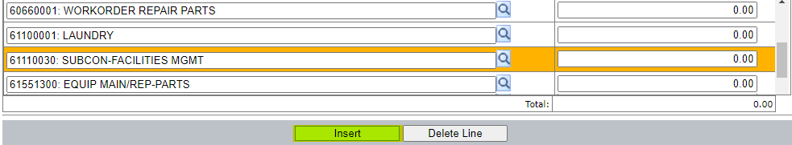

This will bring up “Insert Options”. Select the “Insert Before or After” and click the “Accounts” button.

This will bring up the Account Lookup window. Key in the account number in the filter field.
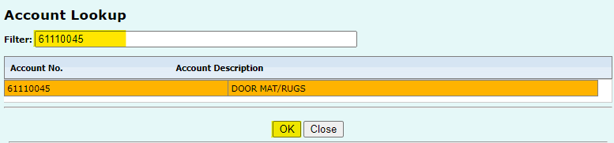

Click to highlight the desired account then click OK. The new row fills in the account number automatically. Click in the Distribution Amount field and enter the amount for the new account number.
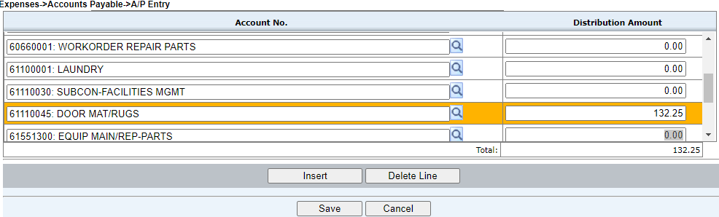

Continue this process until all required accounts have been added and distribution amount entered.

Note: The new account is only active for this accounts payable entry action, and is not saved into the pre-defined list of accounts.

