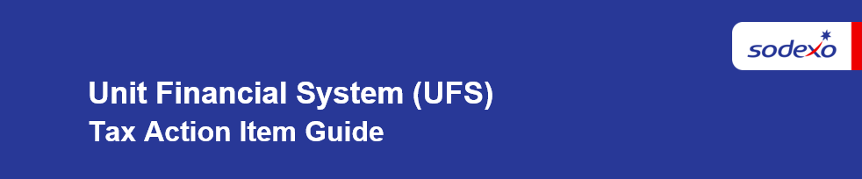

Unit Financial System (UFS) Tax Action Item Guide

Updating Register in Cash Setup with New Vape Tax Rate

Tax Rates - PST tax code 140 will automatically be updated in the maintenance module
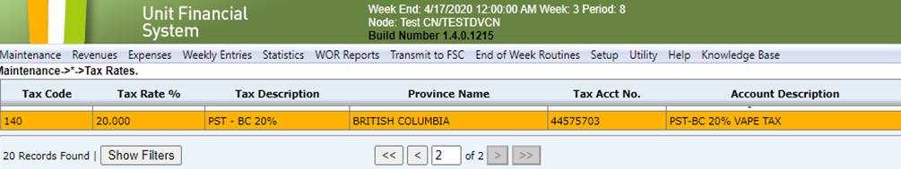
Steps to update Register in Cash Setup
Navigate to Revenue > Cash Setup > Register
- Select Register to update and click Edit
- Click Tax Rates and click the look up icon and select proper tax code to update with new rate
- Click OK and Save. Repeat this process until all Registers have been updated
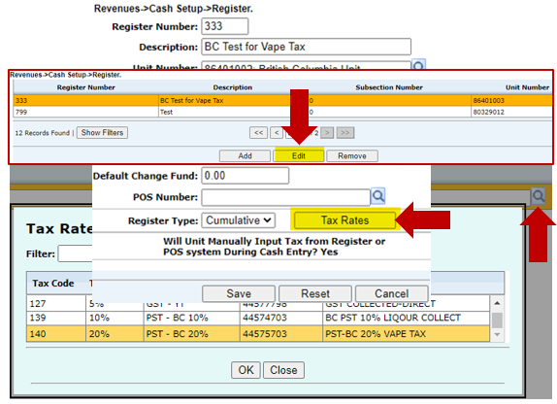

Cash Entry – Register Receipts & Tax
Confirm the updated PST rate appears in cash entry, Register Receipts & Tax
