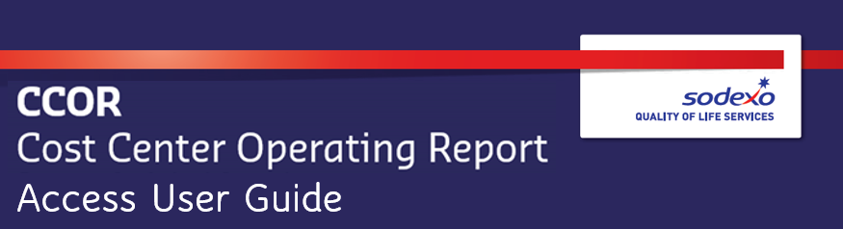
Requesting Fiori Access for Cost Center Operating Report (CCOR)
Navigate and log in to the Information Security Access Request form (Internet Explorer is the only compatible browser at this time. Chrome or Edge will cause form issues): https://sodexhoinfo-usa.com/IST/ISAPPV2.NSF/Launch?OpenForm
- Click on Request Access
- Select Employee Type
- Enter Employee ID (HR Benefits ID for Canada users) and click Retrieve
- Expand Finance Section
- Click on SAP option (not SAP role change)
Two access request forms are required to gain access to CCOR. The two screenshots below show the form for request #1 and #2, highlighting the correct information for required fields:
