Cost Center Operating Report (CCOR) User Guide

Log in to SAP Fiori
Access outside of UFS:
- STEP 1: Go to the below web link by clicking on it or copy & paste in an internet browser window. https://noramsap.mysodexo.com/fiori
- STEP 2: If the sign in screen appears, enter your Sodexo network username and password, and click on the Sign in button
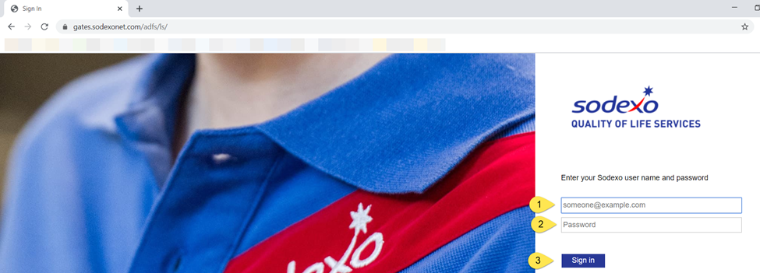
Or, access within UFS:
- UFS Users can access the CCOR by clicking on the sub-menu option “External – Cost Center Operating Report” under “WOR Reports” menu as shown in example below
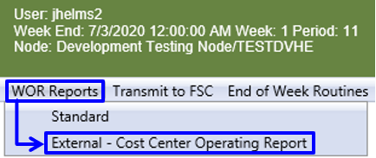
- STEP 3: Choose the tile for Cost Center Operating Report as highlighted in image below

Starting a Report

After selecting the CCOR tile button, a list of available Cost Center’s will display. Select a Cost Center from this list to start a report. As shown in the sample image below:
- The light/dark blue header will always appear at the top, regardless of where you navigate within CCOR.
- The back arrow will return you to the previous screen.
- The home icon will return you to the above screen with the
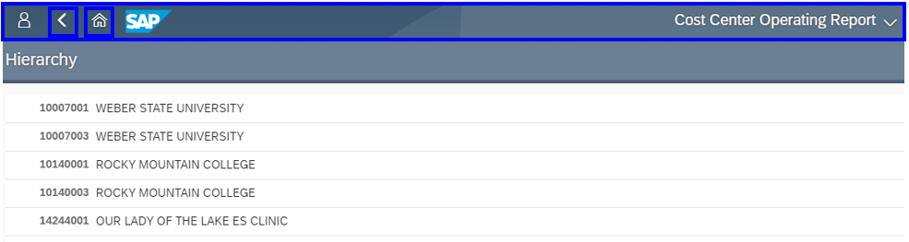
Once you have selected the cost center, the screen will split to show report options on the right. As indicated by arrows in the image below:
- Choose the desired financial period from the drop down.
- Choose the desired report from the drop down.
- Check the box if desired report should be at main-loc/site level (roll up) vs. the individual unit.
- Once the options are chosen, click GO
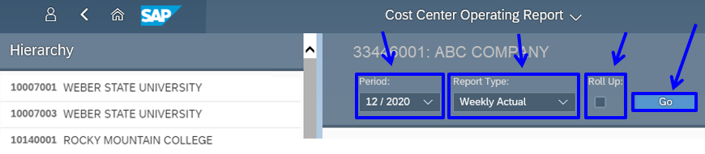

Individual Unit Report
  - Report: Weekly Actual
Once “Go” is chosen, the report will display similar to the image below as shown marked with arrows:
- Click the arrows located at the left of the screen, before each description, to expand each individual node to the next level
- Report is a weekly view, with the monthly “Total” in the left most dollar column, followed by each Friday week-ending date. Dates that are displayed in blue are partial weeks. The March calendar is used for the below examples:
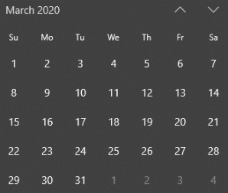 | - Week ending 3/6 includes 6 days  - Week ending 3/13, 3/20 and 3/27 are full weeks (7 days)  - Week ending 3/31 includes 4 days
- Expand/Collapse – use the left button of double down arrows to expand the report to the next level; use the right button of double up arrows to collapse all
- Click the small square icon in the upper right-hand corner to expand report to full screen. Click again to return to split screen with the list of Cost Centers on the left.
- Choose Export icon to download the report; the file will show in the lower left corner. Click to open in Excel.
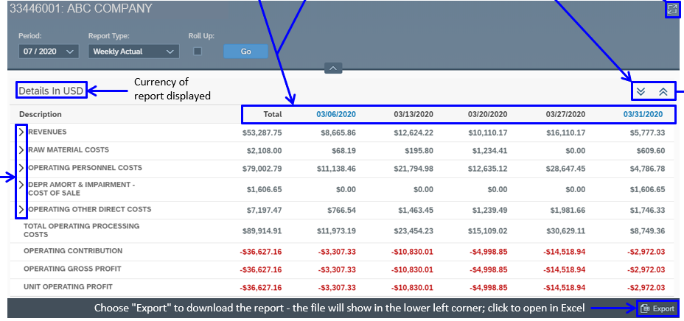
  - Report: Expanded view
To expand the ledger account sections, as highlighted in the image below:
- Hover over any of the descriptions until a hand icon appears, and click to expand for further detail on that individual description or
- Click the arrow on the far-right side of the row
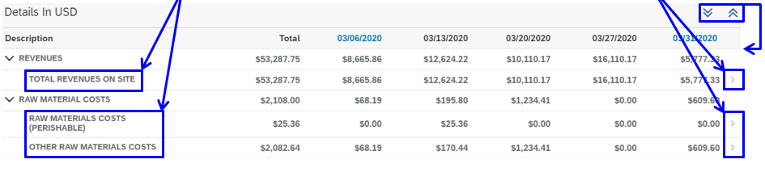
If you click to expand an individual description, a new window will open to display only the description chosen. As indicated by arrows in the image below:
- Choose the arrow on the left to expand 1 level at a time
- Choose the double down arrow on the right to fully expand the entire report down to individual GL Account and Doc Type level
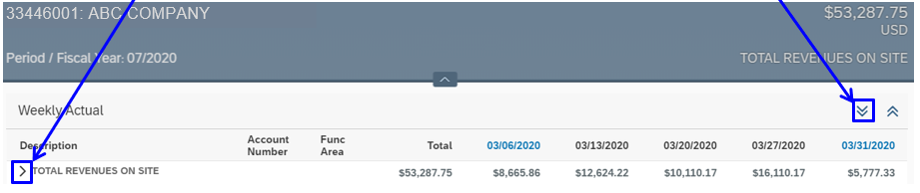
Total Revenues on Site: Expanded to GL account and Doc Type level view
Once you have expanded the entire report down to GL account and Doc Type level, hover over any of the GL account #’s until a hand icon appears and click for further detail. A new window will open displaying each individual transaction for that account #. Use “Revenue-Full Service” as an example as shown in image below:
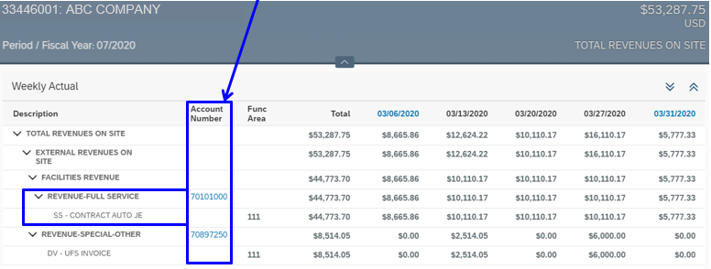
  - Revenue-Full Service: Individual Transaction Level
Once you are in report view to display each individual transaction for the GL account, the results function similar to an Excel spreadsheet. As highlighted in image below, indicated by arrows:
- Columns can be rearranged in any order by dragging the column header title to the right or left
- Column width can be widened or narrowed by dragging the light blue line that appears when hovering between columns
- Clicking any header will display a drop-down menu of options to sort, filter, group and freeze columns
- Click on clear group icon to ungroup or clear filters, returning the results to original display
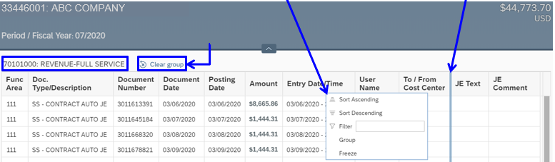

Roll Up Report
If you choose “Roll Up” report option, the header will include this text next to the Cost Center name. The below results include a combined view for Cost Centers 33446-001, 002 and 003.
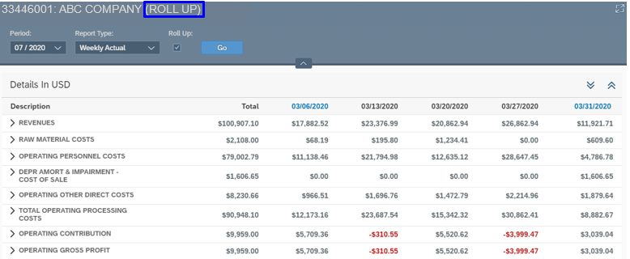
Revenues and Raw Material Costs expanded to show totals at Cost Center level
When in Roll Up view if you click a GL line to expand it, you will see the individual cost center totals that make up the roll up total. As shown in the image below:
- Revenues GL line expanded shows 3 separate cost centers that roll up to the total of $100,907.10
- Raw Material Costs of $2,108 comes from only the 001 cost center
- Similar to the non-roll up report above, the arrows can be expanded further to view more detail down to the individual transaction level. For example, the 001 cost center under Raw Material Costs is further broken out by Perishable and Other. Click those descriptions to drill down to individual GL account, doc type and transaction level.
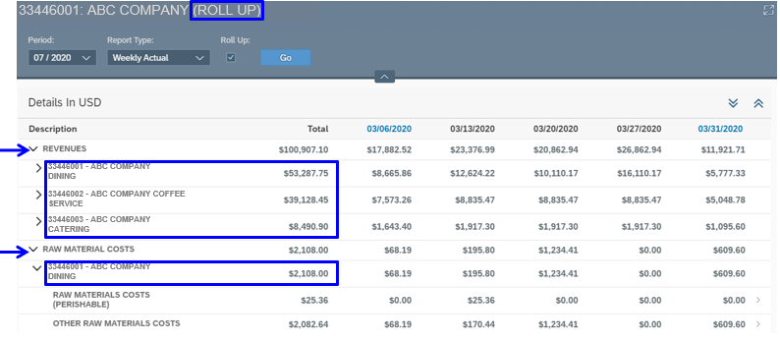

Additional Information:
- CCOR is on demand real-time. Once a transaction posts in SAP, it will be immediately reflected in CCOR. This includes transactions like a new equipment purchase - once the asset is setup in SAP, depreciation expense will increase to reflect the addition of the new asset.
- UFS transmissions without errors will post to SAP in approx. 1 hour, at which time it will be reflected in CCOR.
- Deprecation, Labor, and Sales Expense are the only estimates at this time.
- Estimates will post daily as a weekly expense amount.
- Estimates will eliminate the need for standard and weekly account entries.

Explanation of All Report Types
The functionality and procedure for running a report is the same for all available reports. See below for further details and differences with the remaining reports.
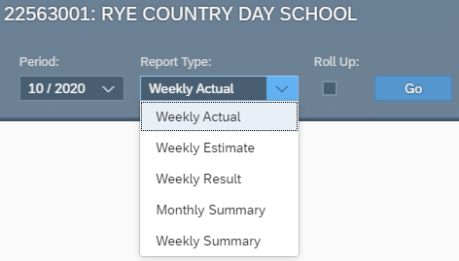
Weekly Estimate: purpose is to provide estimates for Fiori sales, labor expense and depreciation expense
- Sales estimates are based on activity entered into Fiori but not yet billed
- Labor estimates:
  - US - activity entered into Kronos
  - CAN - based on last 4 weeks of posted labor expense
- Depreciation estimates are based on month-to-date asset activity
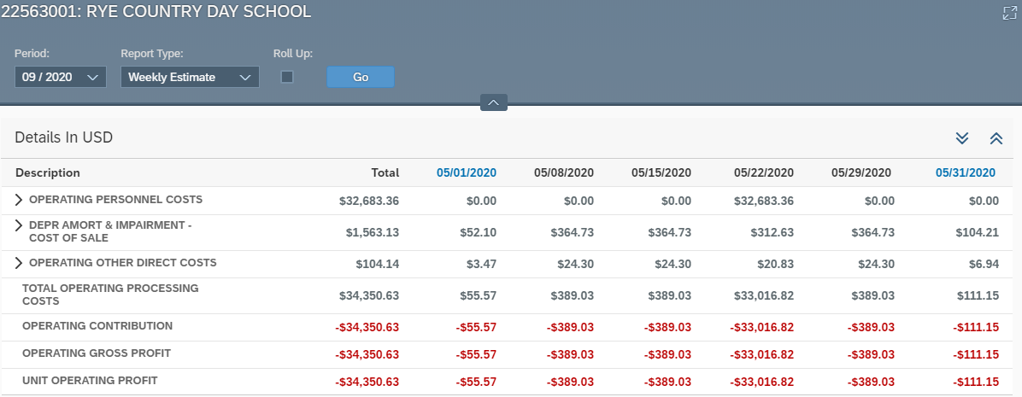
Weekly Result: purpose is to provide weekly flash amounts for each Friday week-ending date of the month and will match the results column in the Weekly Summary report
- Weekly flash amounts represent:
  - Posted actual sales and expenses
  - Estimates for sales and expenses that have not yet posted
  - Estimated Unit Operating Profit
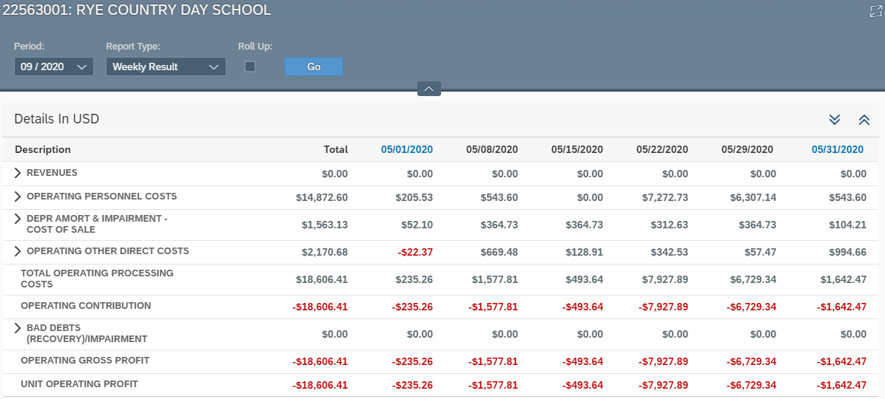
Monthly Summary: report will display Actuals and Estimates for the month chosen
- Actuals will match the Total column of the Weekly Actual report
- Estimates will match the Total column of the Weekly Estimate report
- Same drill-down functionality to view account level details
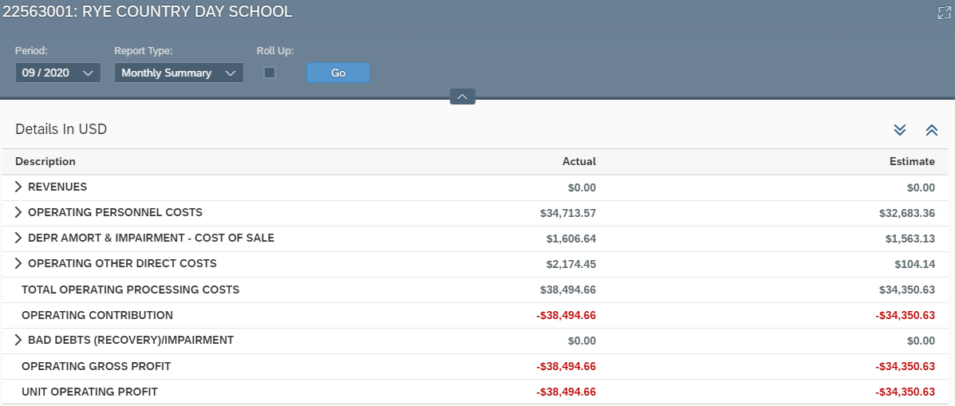

Weekly Summary: report will display Actuals, Estimates and Results for the week chosen
- Actuals will match the Weekly Actual report for the same week ending
- Estimates will match the Weekly Estimate report for the same week ending
- Results column is the weekly flash amounts:
  - Posted actual sales and expenses
  - Estimates for sales and expenses that have not yet posted
  - Estimated Unit Operating Profit
